Bastyr University – Seattle
14500 Juanita Drive NE, Kenmore, WA 98028
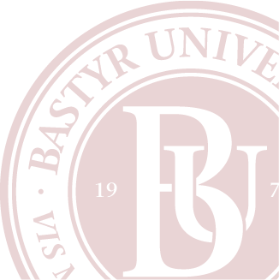
Phone: 425-602-3000

