Bastyr University – San Diego
4106 Sorrento Valley Boulevard, San Diego, CA 92121
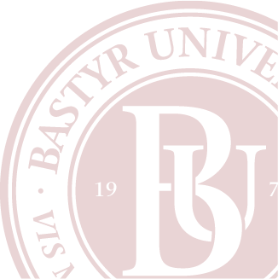
Phone: 858-246-9700

